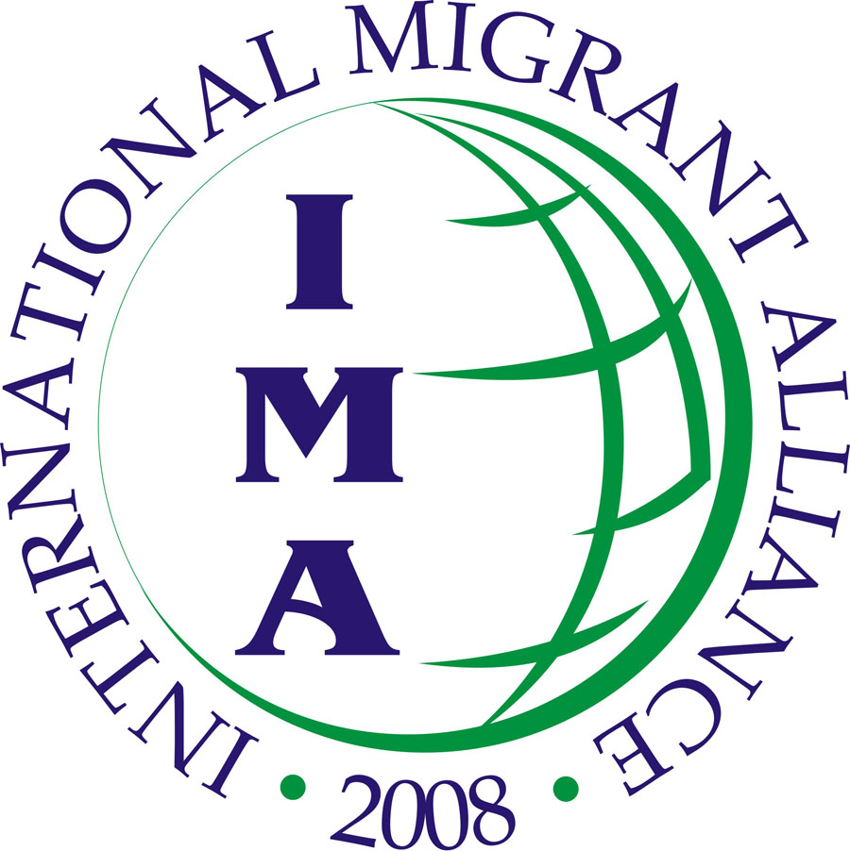
International Migrant Alliance
c/o Asia Pacific Mission for Migrants
Ground Floor, No. 2 Jordan Road, Kowloon, HK SAR
Tel No (852) 27237536 Fax No. (852) 27354559
Email: ima.sect@gmail.com Website: www.pinas.net/ima

Stop AIDS, Lead the Action!
Empower the Victims and Community
Deliver the Services

Good afternoon ladies and gentlemen!

On behalf of the International Migrant Alliance (IMA) and the Asian Migrants Coordinating Body (AMCB), I would like to congratulate the St. John’s HIV Education Center for a very successful HIV festival today. Let me take this opportunity to extend our support and solidarity to the victims of HIV, their fight against the disease, their struggle for better health services, and for those who are with them in such struggle.

The success of HIV Festival today is a proof of solid cooperation and unity among migrant workers, different local organizations and institutions in Hong Kong, that have come together every year to tackle the common cause, lead the actions and empower the victims and the community to STOP AIDS.

Health is definitely important for all of us; from physical to mental to psychosocial because this is the only source of wealth and resource we can rely on to continue living and working. Thus, service for health should be provided and ensured by our government including treatment and services for people affected by HIV/AIDS.

However, under neoliberal globalization, basic services including health are unfortunately being privatized and have become more inaccessible to the people, especially the poor. Such economic framework is also the main reason why a few years ago, the Hong Kong government began charging HK$100 per hospital admission. In many of underdeveloped countries, health services are extremely expensive that it is now impossible for the majority of people to afford it.

Let me emphasize that due to nature of migration for majority of migrant workers are encountered today, which is a forced one, and types of work we perform, we are not exempted in acquiring HIV/AIDS virus and other diseases. In fact we are very vulnerable to develop these diseases. However, instead curing the disease and providing accessable medical care, many receiving governments impose discriminative policies against migrant workers such as mandatory testing for HIV/AIDS.

In Hong Kong, the employment ordinance stipulates that employers to be responsible for our health care fees by requiring them to obtain medical insurance for us. Unfortunately, either not many of us are aware of this or our employers do not implement it. This is not to mention the fact that the insurance provided to us usually does not cover the more serious illnesses that we oftentimes also get because of nature of our job.

Many migrant workers have also raised complaints that their employers have denied their right to see a doctor or rest when they are sick. If ever they are allowed to do so, then they are made to pay with their own money.

In many cases, the health problems of FDWs are caused by the working conditions and environment we are, in which can be described as difficult, dangerous and dirty. As live-in domestic helpers, we are forced to work long hours and are 24-hours on call that gives us with very insufficient time to rest.

Among Indonesian migrant workers alone, based on ATKI survey conducted in 2005, 61% suffer from long working hours and 54% are not given their legal day-off. But due to fear of losing the jobs, many FDWs are afraid to show or tell the employers of their sickness and just endure their harsh condition.

Take the lead and act now!

There is no other way but to fight AIDS pandemic, address conditions that cause its spread and stop discrimination against victims of AIDS. This festival has been organized to reaffirm our commitment to do this.

We should empower AIDS victims for them to face the issue with strength and unity. We should educate and empower our fellow migrant workers in Hong Kong to speak out and demand to their employers for medical treatment when they need it and to stop various forms of maltreatment because health is completely important for migrants whose families depend on for survival.

For NGOs and advocates, they play a big role in facilitating the empowerment of the victims and advocating for better protection and services from the government and international institutions.

Governments should deliver their promises in providing service to the people. In the case of Hong Kong government, this will include monitoring employers in Hong Kong whether they have fulfilled their responsibility in shouldering the medical treatment of their FDWs and providing sufficient rest and accommodation to their workers.

Finally, let us take a lead and reaffirm our commitment in ensuring the protection to our health rights and better working condition. The problem of HIV/AIDS is a part and parcel of whole other issues of migrant workers. These, we shall face together so we can succeed.

Thank you and good day to all of us.

Eni Lestari
Chairperson

